ML System Design Document Project Scope and Team Workflows
Retrieval Augmented Product Question Answering
This document defines the scope, team workflow, end-to-end ML architecture, release process, security controls, and operating plan for an evidence-based product question-answering prototype. The design is feasible in an AWS Academy Learner Lab with a $100 budget by using a limited dataset, CPU-first models, temporary SageMaker endpoints, manual labeling, and strict resource cleanup.

Team Information
Field | Value
Project Team Group | Two-member team: Manoj Patra and Raminder Singh
Authors | Manoj Patra and Raminder Singh
Business and System Name | Retrieval Augmented Product Question Answering
Document Version | 1.0
Publication Date | September 14, 2026
Document Status | Design proposed for implementation

Team Workflows

Project Links
Resource | Current Value
GitHub Project | Not provided
Asana Board | Not provided
Team Tracker | Not provided
AWS Region | Proposed primary region: us-east-1
Model Registry Group | product-qa-ranker, if Learner Lab permissions allow

Development Workflow
The team will keep the main branch deployable and use short-lived feature, fix, and experiment branches. Every pull request will link to a tracked task and state the purpose, tests, affected data or model artifacts, measured results, expected AWS cost, and rollback procedure. Manoj and Raminder Singh will review each other's work before merge.
1. Create an issue with an owner, acceptance criteria, and estimated AWS cost.
2. Implement the change on a short-lived branch and run local tests.
3. Open a pull request with evidence from data, model, or application tests.
4. Obtain review from the second team member and merge after CI passes.
5. Run the approved data, training, or deployment pipeline.
6. Record the dataset, code, container, model, and index versions in the team tracker.
7. Stop or delete billable compute immediately after the work session or demonstration.

Team Responsibilities
Activity | Responsible Role | Approver | Required Output
Project scope and acceptance criteria | Manoj Patra, Project Lead | Raminder Singh | Approved requirements and acceptance criteria
Data ingestion and validation | Raminder Singh, Data Engineering Lead | Manoj Patra | Versioned dataset, schema, and data-quality report
Data preprocessing and feature engineering | Raminder Singh, Data Engineering Lead | Manoj Patra | Reproducible processing pipeline and feature definitions
Retrieval and ranking model development | Manoj Patra, ML Engineering Lead | Raminder Singh | BM25 baseline, semantic retriever, and trained ranking model
Model evaluation and error analysis | Manoj Patra, ML Engineering Lead | Raminder Singh | Evaluation report, baseline comparison, and error analysis
AWS infrastructure and CI CD pipeline | Manoj Patra, MLOps Lead | Raminder Singh | Reproducible SageMaker pipeline and AWS resources
Flask API and web application | Raminder Singh, Application Engineering Lead | Manoj Patra | Tested API and deployed demonstration interface
Security and privacy review | Raminder Singh, Security and Data Review Owner | Manoj Patra | Completed security, privacy, and risk checklist
Integration and release testing | Raminder Singh, Quality Assurance Lead | Manoj Patra | Test report and completed release checklist
Model registration and deployment | Manoj Patra, MLOps Lead | Raminder Singh | Approved model version and deployment record
Monitoring dashboard and alarms | Manoj Patra, MLOps Lead | Raminder Singh | CloudWatch dashboard, baseline, and tested alarms
Documentation and presentation | Manoj Patra and Raminder Singh, Joint Owners | Manoj Patra and Raminder Singh | Final design, model card, runbook, and demonstration

Project Scope

Project Background
We will build a product question-answering system for an e-commerce setting. Given a customer question and product identifier, the system will retrieve relevant product attributes, descriptions, prior questions, community answers, or reviews and return a concise answer supported by that evidence. Each response will include the supporting source, confidence score, model version, and index version. When the evidence is insufficient or contradictory, the system will return a no-answer response.
The primary machine learning problem is supervised evidence relevance ranking within a retrieval-augmented architecture. The minimum viable product will return the highest-ranked existing answer or evidence passage. Constrained answer generation is an extension and will only run after retrieval, ranking, confidence filtering, and groundedness checks. The first release will support English questions and a limited product-category subset.

Technical Background
The system will use two retrieval stages. BM25 and sentence embeddings will produce a candidate set. A supervised learning-to-rank model will then combine semantic similarity, lexical overlap, source type, question type, and candidate-quality features. BM25 supplies a reproducible baseline. A frozen MiniLM sentence encoder and FAISS index provide semantic retrieval without the cost of transformer fine-tuning.
The primary ranker will be LightGBM LambdaRank. Logistic regression will provide an interpretable baseline, and a compact cross-encoder will remain a stretch experiment. Model selection will use held-out questions and relevance labels. The main metrics will be Precision at K, Recall at K, Mean Reciprocal Rank, and NDCG at K. Optional generated answers will be evaluated separately for correctness, usefulness, groundedness, and unsupported claims.

Goals
• Build a reproducible pipeline for ingesting, cleaning, splitting, featurizing, and versioning product question-answering data.
• Compare BM25 retrieval with semantic retrieval and supervised reranking.
• Train a model that ranks evidence for each product question and abstains when confidence is low.
• Deploy a real-time prototype and a repeatable offline evaluation workflow.
• Define monitoring baselines, release tests, cost controls, and a model approval process.

Non Goals
• Training a large language model from scratch.
• Building a complete shopping website or enterprise customer-support platform.
• Supporting every product category, language, or traffic pattern in the first release.
• Generating answers without retrieved evidence.
• Providing multi-region availability, enterprise autoscaling, or formal production service guarantees.

Functional Requirements
ID | Requirement
FR1 | Accept an English product question and product identifier or context.
FR2 | Retrieve and rerank candidate evidence for the requested product.
FR3 | Return the best answer with evidence, source type, and confidence.
FR4 | Return an explicit no-answer result below the approved threshold.
FR5 | Support offline evaluation, batch index rebuilding, and reproducible runs.
FR6 | Associate every response with model, preprocessing, and index versions.
FR7 | Collect optional helpful, not helpful, and unsupported feedback.

Learner Lab Constraints
• The total AWS budget is $100, with an internal operating target of $60 and the remainder reserved for failed jobs and the final demonstration.
• The build will use a category subset and CPU-first models. GPU work is optional and capped at three to four hours.
• The SageMaker endpoint will exist only during integration testing and the final demonstration.
• Feature Store, Amplify, Pipelines, and Model Registry are conditional on the permissions assigned to the Learner Lab.
• S3 manifests and EC2-hosted inference provide fallbacks when a managed service is blocked.

Solution Overview
Public data will be copied into a private, versioned S3 raw area. SageMaker Processing will validate the schema, clean the text, remove duplicates, produce deterministic splits, and create candidate evidence groups. A CPU embedding job will create MiniLM vectors and a FAISS index. Training jobs will compare BM25, dense similarity, logistic regression, and LightGBM. A candidate will be registered only when it passes the defined quality, latency, security, and budget gates.
During normal development, Flask will load the approved model and FAISS index on a small EC2 instance. A temporary SageMaker endpoint will be created for final integration testing when Learner Lab permissions allow it. CloudWatch will receive operational and custom model-quality metrics. The team will use manual or daily monitoring jobs rather than continuous paid monitoring.
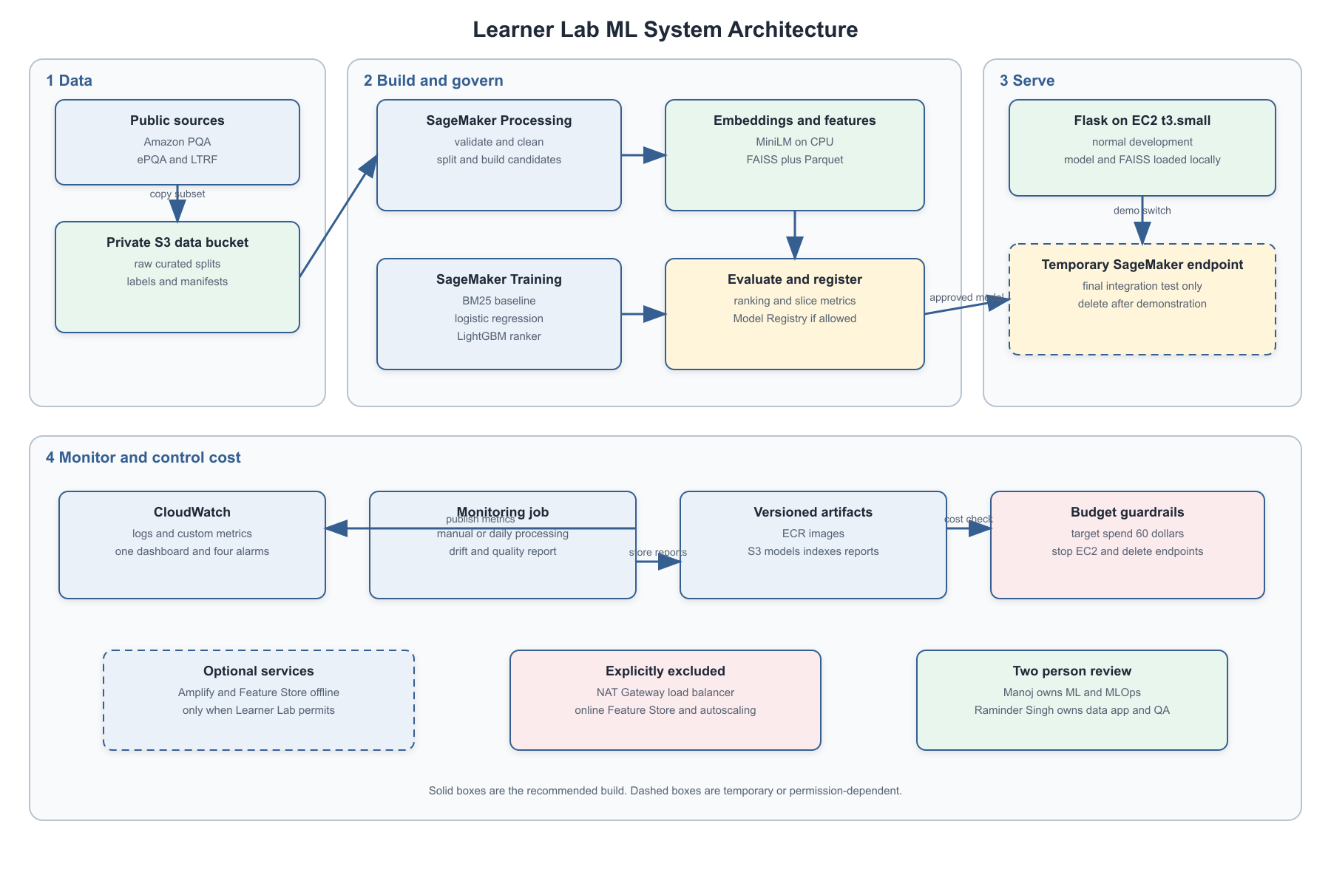
Figure 1 Learner Lab ML System Architecture

AWS Service Plan
RFC Service | MVP Decision | Learner Lab Implementation
S3 bucket | Use | One private bucket with raw, curated, artifact, and monitoring prefixes if bucket count is restricted.
SageMaker notebook | Use | ml.t3.medium or ml.m5.large, stopped when not in use.
SageMaker Feature Store | Conditional | Offline store only; versioned Parquet in S3 is the fallback.
Container registry | Use | ECR with only the latest two or three image versions retained.
CloudWatch | Use | Limited logs, one dashboard, and four alarms.
Autoscaling | Omit | Document as a production enhancement.
SageMaker endpoint | Temporary | Create for final tests and demonstration, then delete.
SageMaker Ground Truth | Conditional | Manoj and Raminder Singh label a small sample manually; no paid workforce.
EC2 instance | Use | t3.small for Flask and local inference; stop after each session.
Amplify | Conditional | Use if allowed; otherwise serve a basic interface from Flask.
Flask server | Use | REST API and demonstration interface.

Data Sources
Source | Content and Volume | Planned Use
Amazon PQA | Product questions, answers, ASINs, bullet points, descriptions, brands, and item names. The full archive is 2.1 GB compressed and 17.3 GB uncompressed. | Use one category and no more than approximately 25,000 to 50,000 usable records for the first experiment.
ePQA | Three-level relevance labels, evidence source, context, and manually written answers. The English release has 131,520 train and development pairs and 20,142 test pairs. | Primary supervised ranking and answer-evaluation dataset.
hetPQA | Evidence from six heterogeneous source types. | Secondary source-type analysis if time permits.
LTRF CQA | Product questions, answers, and answer-quality labels. | Optional answer-quality filtering experiment.
Team labels | A reviewed sample produced by Manoj and Raminder Singh. | Validate weak labels, abstention, and groundedness.

ePQA is the primary training source because it supplies explicit relevance labels. Amazon PQA supplies a larger retrieval corpus and product metadata. The category subset keeps embedding time, processing time, and storage within the Learner Lab budget.

Data Risks
• Public answers may be subjective, outdated, incorrect, or inconsistent.
• User-generated text may contain incidental personal information or unsafe language.
• Popular categories and products may be overrepresented.
• Random row-level splitting could leak near-duplicate products or questions.
• Weak negative sampling may incorrectly label useful evidence as irrelevant.
• Historical datasets must not be used as evidence for current price, inventory, warranty, or safety information.

Data Engineering

Storage Layout
S3 Prefix | Contents
raw/ | Immutable source files, source metadata, and checksums
quarantine/ | Malformed or policy-rejected records and reason codes
curated/ | Normalized Parquet datasets
splits/ | Immutable train, validation, and test manifests
features/ | Scalar features and optional Feature Store exports
embeddings/ | Question and evidence vectors
indexes/ | FAISS index, metadata, and compatibility manifest
models/ | Model artifacts and evaluation files
monitoring/ | Sanitized inference metrics, baselines, and reports

Processing Steps
1. Copy the selected source files to the immutable raw prefix and record their checksums, license, size, and source date.
2. Validate the required columns, types, label values, and parse success rate.
3. Normalize Unicode, whitespace, HTML, product identifiers, categories, and source names.
4. Remove empty rows and exact duplicates, and group near-duplicates before splitting.
5. Detect English text and scan for email, telephone, address, and payment-card-like patterns.
6. Create candidate groups, weak negatives, hard negatives, and deterministic manifests.
7. Generate scalar features, MiniLM embeddings, and the versioned FAISS index.
8. Publish a data-quality report and stop the pipeline if a blocking rule fails.

Exploratory Analysis
• Rows, unique questions, products, categories, and candidates per question.
• Label balance, positive-to-negative ratio, and evidence-source distribution.
• Question, candidate, context, and answer lengths.
• Missing fields, duplicates, language, and potentially sensitive text.
• Question types such as compatibility, specifications, dimensions, quality, and yes or no.
• Similarity across splits and model performance by category, source, type, and answerability.

Training Data
The official ePQA train, development, and test files will be preserved for benchmark comparability. The ePQA test set will not be used for feature, model, or threshold selection. Amazon-PQA records will use a deterministic 70 percent training, 15 percent validation, and 15 percent test split grouped by ASIN. Near-duplicate questions and candidates will remain in the same split.
ePQA labels map to irrelevant, helpful but incomplete, and fully answering. Existing Amazon-PQA question-answer associations provide initial positive examples. Negative candidates will come from the same product or category, including difficult BM25 and embedding results. Manoj and Raminder Singh will each label 100 to 200 pairs and double-label at least 50 shared examples to measure agreement and resolve ambiguous cases.

Leakage Controls
• Fail when a question identifier or Amazon-PQA ASIN appears in multiple splits.
• Keep near-identical normalized pairs within one split.
• Exclude relevance labels and reference answers from ranker input features.
• Exclude future feedback and fields unavailable at online inference time.
• Keep test records out of feature, threshold, and hyperparameter selection.

Feature Engineering
Feature Group | Examples | Treatment
Text | Question, candidate, context, and product title | Normalize text; preserve negation, measurements, model numbers, and units.
Semantic | MiniLM embeddings and cosine similarity | L2 normalize and compute with the same model version in training and inference.
Lexical | BM25 score, token overlap, phrase and number match | Use as baseline and ranker features.
Metadata | Category, source type, and question type | Encode as categorical features.
Length and quality | Token counts, missing text, duplicate and boilerplate flags | Use for filtering and ranking.
Identifiers | qid, pair ID, ASIN, ingestion version | Use as keys and split controls, not predictive features.
Sensitive data | Names, contact data, payment-like text | Redact or exclude unless required for a documented safety test.

Scalar features will be stored as Parquet in S3 and optionally in the Feature Store offline store. Dense vectors and candidate metadata will be packaged in the FAISS index because they are retrieval artifacts rather than ordinary tabular features.

Model Training and Evaluation

Model Stack
1. BM25 lexical retrieval baseline.
2. Frozen sentence-embedding retrieval using cosine similarity.
3. Logistic regression supervised baseline over retrieval and metadata features.
4. LightGBM LambdaRank as the primary ranking model.
5. Compact transformer cross-encoder as an optional experiment if time and budget remain.
6. Constrained evidence-only answer generation as a future extension.

Initial Parameters
Component | Initial Configuration
Embedding model | all-MiniLM-L6-v2 or equivalent compact encoder
Embedding dimension | 384
Retrieved candidates | Top 50
Reranked candidates | Top 10
Returned evidence | Top 3
LightGBM objective | lambdarank
Learning rate | 0.05
Number of leaves | 31
Maximum estimators | 500
L2 regularization | 1.0
Early stopping | 50 rounds
Random seed | 42

Evaluation and Release Gates
Area | Metric | Initial Gate
Retrieval | Recall at 10 | At least 0.85 and 0.05 above BM25
Ranking | Mean Reciprocal Rank | At least 0.05 absolute improvement over BM25
Ranking | NDCG at 10 | At least 0.03 absolute improvement over BM25
Top answer | Precision at 1 | No regression from the best approved model
Confidence | Expected calibration error | No greater than 0.10
Abstention | No-answer precision | At least 0.90 on the reviewed set
Groundedness | Unsupported claim rate | No greater than 5 percent
Serving | Extractive p95 latency | No greater than 2.5 seconds
Serving | Error rate | Less than 1 percent in the load test

The thresholds are initial design targets and will be recalibrated after the baseline run. The evaluation report will include bootstrap confidence intervals and slices by category, evidence source, question type, text length, and answerability. A higher aggregate score will not override a serious regression in a high-risk slice.

Model Deployment

Deployment Pattern
The user-facing application needs interactive responses, but an always-running SageMaker endpoint is not affordable under the lab budget. During routine development, a t3.small EC2 instance will run Flask, the MiniLM encoder, the FAISS index, and the approved ranker. For final integration testing, the team may deploy the same inference container to a SageMaker real-time endpoint for 12 to 20 total hours and delete it immediately afterward.
Workload | Initial Compute | Cost Control
Exploration | SageMaker ml.t3.medium | Stop when unused; target 60 to 80 hours total.
Data processing | ml.m5.large or ml.m5.xlarge | Run on the selected category only.
BM25 and LightGBM | ml.m5.xlarge | CPU training with early stopping.
Optional transformer | ml.g4dn.xlarge | Maximum three to four hours.
Routine inference | EC2 t3.small | Stop after each work session.
Final endpoint test | SageMaker ml.m5.large or ml.m5.xlarge | Temporary deployment only.

Online Inference Flow
1. The client sends a product identifier, English question, and unique request identifier to Flask.
2. Flask validates the schema, payload size, and request rate.
3. The inference service normalizes and embeds the question.
4. FAISS retrieves the top 50 candidates, restricted by product or permitted category context.
5. The service calculates lexical, semantic, source, length, and quality features.
6. LightGBM reranks the top 10 candidates and produces a calibrated confidence score.
7. The system returns the best extractive answer and up to three evidence passages, or abstains below the threshold.
8. The API records sanitized metrics, model version, index version, latency, and optional feedback.
The model package will include a compatibility manifest binding the model to its preprocessing version, feature schema, embedding model, and FAISS checksum. Deployment will fail when those versions do not match. Rollback will restore the previous approved model and its associated index.

Model Monitoring
A scheduled or manually executed SageMaker Processing job will compare sanitized inference samples with the approved validation baseline. This custom approach is suitable for a Learner Lab because SageMaker Model Monitor access may be unavailable and AWS no longer opens Model Monitor to new customers. The job will publish custom quality and drift metrics to CloudWatch and store the detailed report in S3.
Area | Metrics | Initial Alert
Infrastructure | CPU, memory, disk, endpoint state | Resource use above 80 percent for 15 minutes
API | Requests, p50 and p95 latency, 4xx and 5xx | 5xx above 1 percent or p95 above 2.5 seconds
Input quality | Missing product, empty question, invalid schema | Invalid request ratio above 2 percent
Drift | Category, topic, length, and embedding distributions | Population Stability Index above 0.20
Retrieval | Top score, score margin, Recall at 10, MRR | Metric drop above 5 percentage points
Answerability | Confidence and no-answer rate | No-answer rate exceeds twice the baseline
Groundedness | Unsupported or contradictory answer rate | Above 5 percent in the reviewed sample
Feedback | Helpful rate and reported errors | Helpful rate drops by 10 percentage points
Cost | Notebook, EC2, processing, training, and endpoint hours | Projected total exceeds the $60 operating target

Model CI CD
SageMaker Pipelines will orchestrate processing, embedding, training, evaluation, and registration when the Learner Lab role permits the required actions. A scripted sequence using the same manifests and quality checks will provide a fallback. Automatic training may create a candidate, but promotion requires review by the second team member.
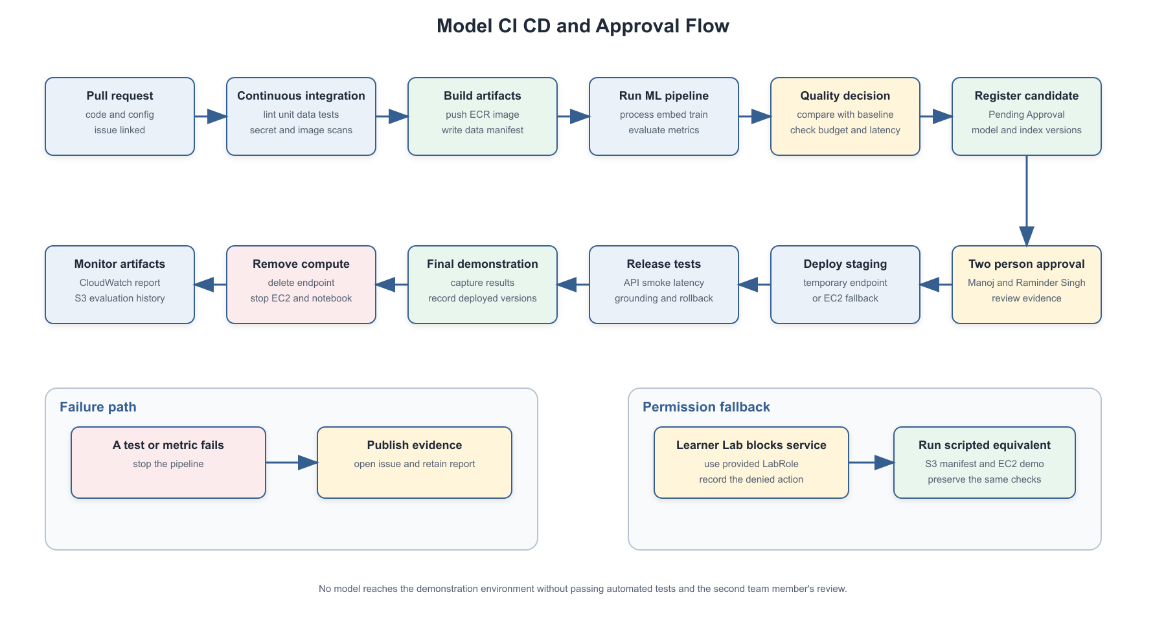
Figure 2 Model CI CD and Approval Flow

Release Tests
Checkpoint | Required Evidence
Pull request | Formatting, linting, unit tests, secret scan, and dependency scan
Ingestion | Schema, checksum, parsing, required columns, and license manifest
Preparation | Null, duplicate, language, label, and split-integrity tests
Features | Ranges, deterministic output, and training-inference parity
Retrieval | Known-query tests, product filtering, and index checksum
Model | Reproducibility, baseline comparison, slices, and calibration
Safety | Grounding, contradiction, PII, unsafe text, and prompt-injection tests
Container | Image scan, health route, non-root process, and version compatibility
Staging | API contract, smoke, latency, load, failure handling, and rollback
Release | Second-member approval, monitoring enabled, and cost checked

Security Privacy and Other Risks

Security Checklist
Question | Decision and Control
Will the system process PHI | No PHI is intentionally collected. Health-related text is untrusted and will not be used for medical advice.
Will the system process PII | Potentially. Public answers and live questions may contain incidental PII. Redact it before monitoring or long-term storage.
Will user behavior be tracked | Only minimum operational telemetry and explicit feedback. No cross-session user profile is planned.
Will credit card data be stored | No. Reject or redact payment-card-like text.
Why retain any user data | Sanitized samples and feedback support debugging, monitoring, and reviewed evaluation.
Which S3 resources are read | Public Amazon-PQA and LTRF sources plus the private project data prefix.
Which S3 resources are written | Private project data, artifacts, and monitoring prefixes only.
Are protected attributes features | No. They are excluded from planned predictive features.

Security Controls
• Use the provided LabRole and least-privilege policies available in the class environment.
• Block public access to project buckets and encrypt stored artifacts.
• Use TLS and keep credentials out of source code and notebooks.
• Validate payload size and type, escape displayed evidence, and rate-limit the public demonstration.
• Retain only sanitized logs for a limited period.
• Scan dependencies and ECR images and keep only required image versions.
• Treat retrieved passages as untrusted data and never as executable instructions.

Bias and Ethical Risks
The model does not require demographic attributes, but it can inherit bias from category coverage, product popularity, language, and subjective community answers. Performance will be reported by category, source, question type, product popularity, and answerability. A small counterfactual set will check whether irrelevant demographic terms change the ranking.
Incorrect compatibility, electrical, child-safety, or product-use answers can create financial or physical harm. The interface will display evidence, distinguish community opinions from manufacturer information, preserve measurements and negation, and abstain when evidence is missing or contradictory. Historical data will not support claims about current price, inventory, warranty, or regulatory status.

AWS Learner Lab Budget Plan
The core project is feasible within the $100 Learner Lab budget. The team will treat $60 as the operating limit and reserve the remaining $40 for failed jobs, permissions workarounds, and the final demonstration. Costs below are planning estimates for us-east-1 and should be checked against the lab's actual usage display.
Service | Planned Usage | Estimated Cost
S3 | Up to 30 GB for two months | $1 to $2
ECR | Up to 5 GB of images | Less than $1
SageMaker notebook | 60 to 80 hours on ml.t3.medium | $3 to $6
SageMaker Processing | 15 to 20 CPU hours | $4 to $6
SageMaker Training | 20 to 30 CPU hours | $5 to $10
Optional GPU | No more than four hours | $3 to $5
SageMaker endpoint | 12 to 20 demonstration hours | $3 to $6
EC2 Flask server | 80 to 120 hours on t3.small | $2 to $4
EBS | 10 to 20 GB | $1 to $2
CloudWatch | Small logs, dashboard, and alarms | $2 to $5
Amplify | Small optional static application | $0 to $3
Requests and transfer | Small academic workload | $0 to $3
Contingency | Failed jobs and reruns | $15 to $20
Expected total | Project estimate | $39 to $72

Primary Cost Risk
The SageMaker endpoint is the largest budget risk. At an indicative $0.23 per hour, an ml.m5.xlarge endpoint running continuously for 30 days would cost about $165.60 before other services: $0.23 x 24 hours x 30 days. The endpoint must therefore be temporary. Stopping a notebook does not stop an independent endpoint.

Budget Guardrails
1. Use one AWS Region and check the Learner Lab balance after every compute session.
2. Stop notebook applications and the Flask EC2 instance when work ends.
3. Delete SageMaker endpoints and endpoint configurations after testing.
4. Limit the initial Amazon-PQA subset to approximately 25,000 to 50,000 records.
5. Retain only the latest two or three ECR images and apply S3 lifecycle rules to temporary outputs.
6. Do not create a NAT Gateway, Application Load Balancer, OpenSearch domain, RDS database, online Feature Store, or always-on GPU instance.
7. Tag billable resources with Project, Owner, and DeleteAfter values.
8. Do not start an optional transformer or generation experiment unless at least $40 remains.

Implementation Plan
Phase | Manoj | Raminder Singh | Exit Evidence
Foundation | Repository, LabRole checks, ECR, CI | Task board and application skeleton | Infrastructure and CI checks pass
Data | Review architecture and cost | Ingestion, schema, preprocessing, EDA | Quality and leakage tests pass
Baseline | BM25 and evaluation pipeline | Data and API test fixtures | Reproducible baseline report
Candidate model | Embeddings, FAISS, LightGBM | Feature validation and error review | Candidate exceeds baseline gates
Application | Model packaging and deployment | Flask interface and integration tests | End-to-end staging tests pass
Monitoring | Metrics, dashboard, and alarms | Feedback and security tests | Test alarms and runbook verified
Final release | Model card and deployment record | Release test report and demo | Both members approve submission

Definition of Done
• Code is merged through the two-person workflow and all required tests pass.
• Configuration is reproducible and contains no embedded credentials.
• Dataset, container, model, feature, and index versions are recorded.
• Evaluation results, limitations, costs, and rollback behavior are documented.
• Monitoring and cleanup procedures are tested.
• The README, model card, team tracker, and demonstration materials are current.

Future Enhancements
1. Evaluate a compact cross-encoder when additional GPU budget is available.
2. Add constrained generation with sentence-level evidence checks.
3. Use active learning to prioritize uncertain or high-impact examples for review.
4. Add multilingual retrieval and generation using xPQA.
5. Support incremental index updates and additional product categories.
6. Move Flask to a managed autoscaling platform and use a managed vector service for larger corpora.
7. Add online experiments for confidence thresholds, answer presentation, and user feedback.

References
[1] RFC ML Project Proposal Retrieval Augmented Product Question Answering. Supplied project proposal.
[2] Amazon PQA Registry of Open Data
[3] Amazon PQA Data Documentation
[4] Learning to Rank and Filter Community Question Answering
[5] Amazon Science Contextual Product Question Answering
[6] ePQA and xPQA Dataset Paper
[7] AWS Academy Learner Lab
[8] Amazon SageMaker AI Pricing
[9] Amazon EC2 T3 Instances
[10] Amazon S3 Pricing
[11] Amazon ECR Pricing
[12] Amazon SageMaker Pipelines
[13] Amazon SageMaker Feature Store Concepts
[14] Amazon SageMaker Model Registry
[15] Amazon SageMaker Model Monitor Data Quality

